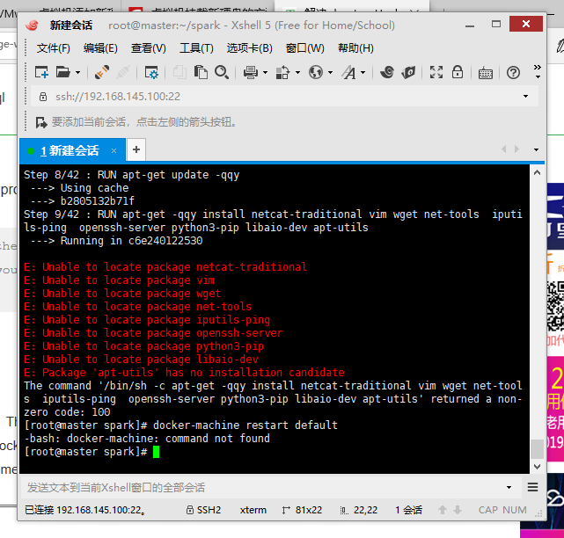

apt-get 报错解决

1、安装docer-machine，在centos里执行下列命令（直接复制所有命令粘贴即可）

base=https://github.com/docker/machine/releases/download/v0.14.0 &&

curl -L $base/docker-machine-$(uname -s)-$(uname -m) >/tmp/docker-machine &&

sudo install /tmp/docker-machine /usr/local/bin/docker-machine

1. 分别执行下面2条命令

$docker-machine restart default *# Restart the environment*

$eval $(docker-machine env default) *# Refresh your environment settings*